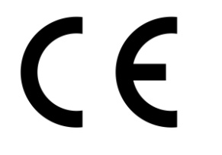
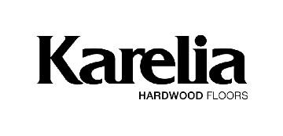
S1
Ver 2020/07

Declaration of Performance
IN ACCORDANCE WITH CONSTRUCTION PRODUCTS REGULATION (EU) NO. 305/2011
All Products Comply with the EU Timber Regulation (EU) No 995/2010

- Unique identification code of the product-type: Karelia Multi-layer Parquet (groups)
- Type, batch or serial number or any other element allowing identification of the construction product. Karelia Upofloor groups
- The product(s) are intended for use as floor coverings(s) within a building according to the manufacturer’s specifications and installation practices in accordance with EN 14342:2013 for CE-Labeling
- Name, registered trade name or registered trademark and contact address of the manufacturer as required pursuant to Article 11(5)
Produced and or marketed by Kährs Holding, AB (publ), Box 805, SE 38228 Nybro, Sweden
- Name and contact address of the authorised representative. Not applicable
- System or systems of assessment and verification of constancy of performance of the construction product. System 3
- Declaration of performance concerning a construction product, the determination of the formaldehyde release was carried out according to the chamber method DIN EN 717-1:2005 the harmonised standard 717-1. Initial type testing report. Notified Body (No. 0766) Entwicklungs- und Prueflabor Holztechnologie GmbH (EPH), Zellescher Weg 24, 01217 Dresden, Germany
- In case of the declaration of performance concerning a construction product for which a European Technical Assessment has been issued: not applicable
- Declared performance EN 14342:2013
Products | CE  Group | Thickness | Reaction to Fire (EN 13501-1) | Formaldehyde Emission (EN 717-1) | Pentachlorophenol Content (CEN/TR 14823) | Slipperiness (CEN/TS 15676) | Thermal Conductivity (EN 12664) | Biological Durability (EN 350-2) | Harmonised Technical Specification
14mm | 513, 260 | 14 mm | Dfl-s1 | E1 | < 5 PPM | NPD | 0,137 W/mK | Class 1 | EN 14342:2013 for CE-Iabelling
13mm | 480 | 13 mm | Dfl-s1 | E1 | < 5 PPM | NPD | 0,14 W/mK | Class 1 | EN 14342:2013 for CE-Iabelling

Accessories | Accessories products are compliant with EEC construction products Directive 89/106/EEC and are produced within the European Community.

- The performance of the product identified in points 1 and 2 is in conformity with the declared performance in point 9.
This declaration of performance is issued under the sole responsibility of the manufacturer identified in point 4.

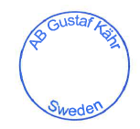
Installation instructions and safety information can be found at www.kareliafloors.com
Signed for and on behalf of the manufacturer by:
Bruce Uhler, Environmental Sustainability - Compliance
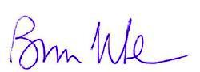
Nybro, Sweden 2020-12-23

