RIELLO INFORMS YOU
RIY_10_2022_Service
26/10/2022
Technical Note

OBJECT: START KIS circulating pump
Dear Sirs,
in a general context of components shortage, Riello activated corrective actions to minimize any inconvenience, to ensure the continuity of production and, therefore, the availability of boilers and spare parts.

To overcome the problem related to the unavailability of the TACO circulating pump, it has been decided to use, as an alternative, two different new components branded SHINHOO and SHIMGE. Those components will be installed in following products:
- START 25 KIS MTN Cod.20187404
- START 30 KIS MTN Cod.20187407
- START 25 KIS GPL Cod.20187772
- START 20 IS Cod.20187773
- START 25 IS Cod.20187774

TACO
SHINHOO
SHIMGE

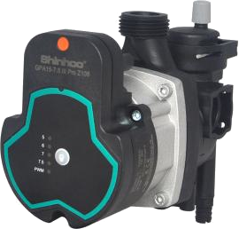
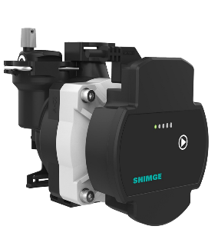
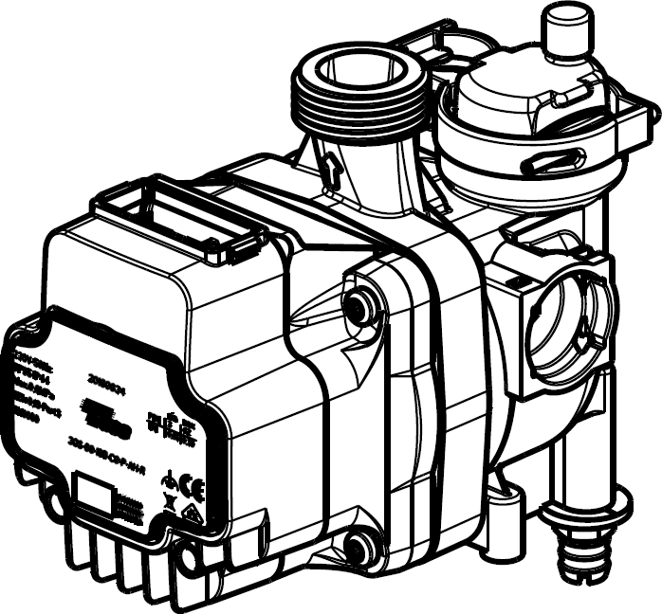

We wish to emphasize that the new circulators (SHINHOO / SHIMGE):
- will be used in alternation to TACO components in brand new boilers
- new components will have the same performances of TACO circulating pumps
- no modifications will be implemented in products user manuals, as the components are perfectly equivalent
BOILERS EQUIPPED WITH SHINHOO CIRCULATING PUMP
The circulating pump will be driven by a PWM signal. Electrical wirings of the PWM signal are MANDATORY for the correct functioning of the boiler, and inhibit the functioning of the onboard button of the circulating pump.
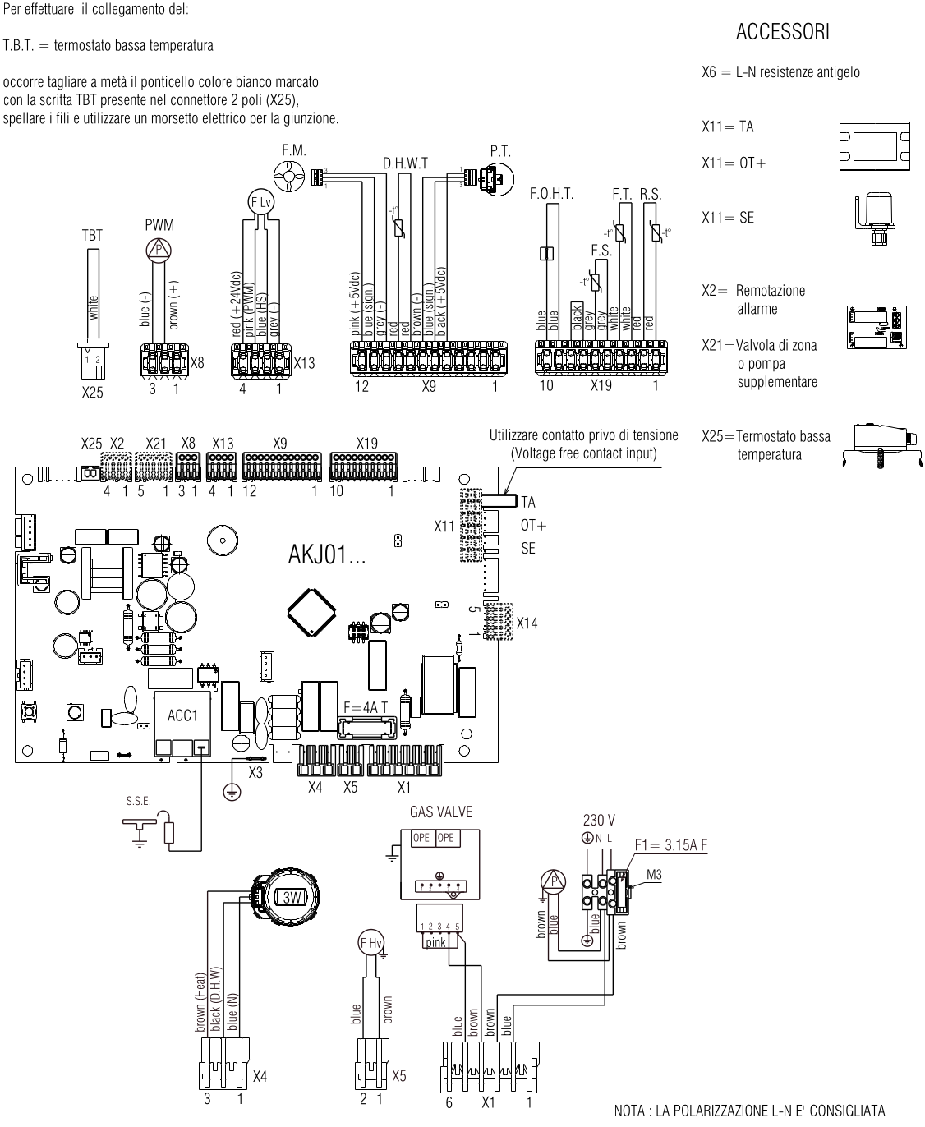
WIRINGS DIAGRAM:

BOILERS EQUIPPED WITH SHIMGE CIRCULATING PUMP
SHIMGE circulating pump will be driven in the same way of the TACO circulating pump.
Onboard button is disabled (no function implemented).
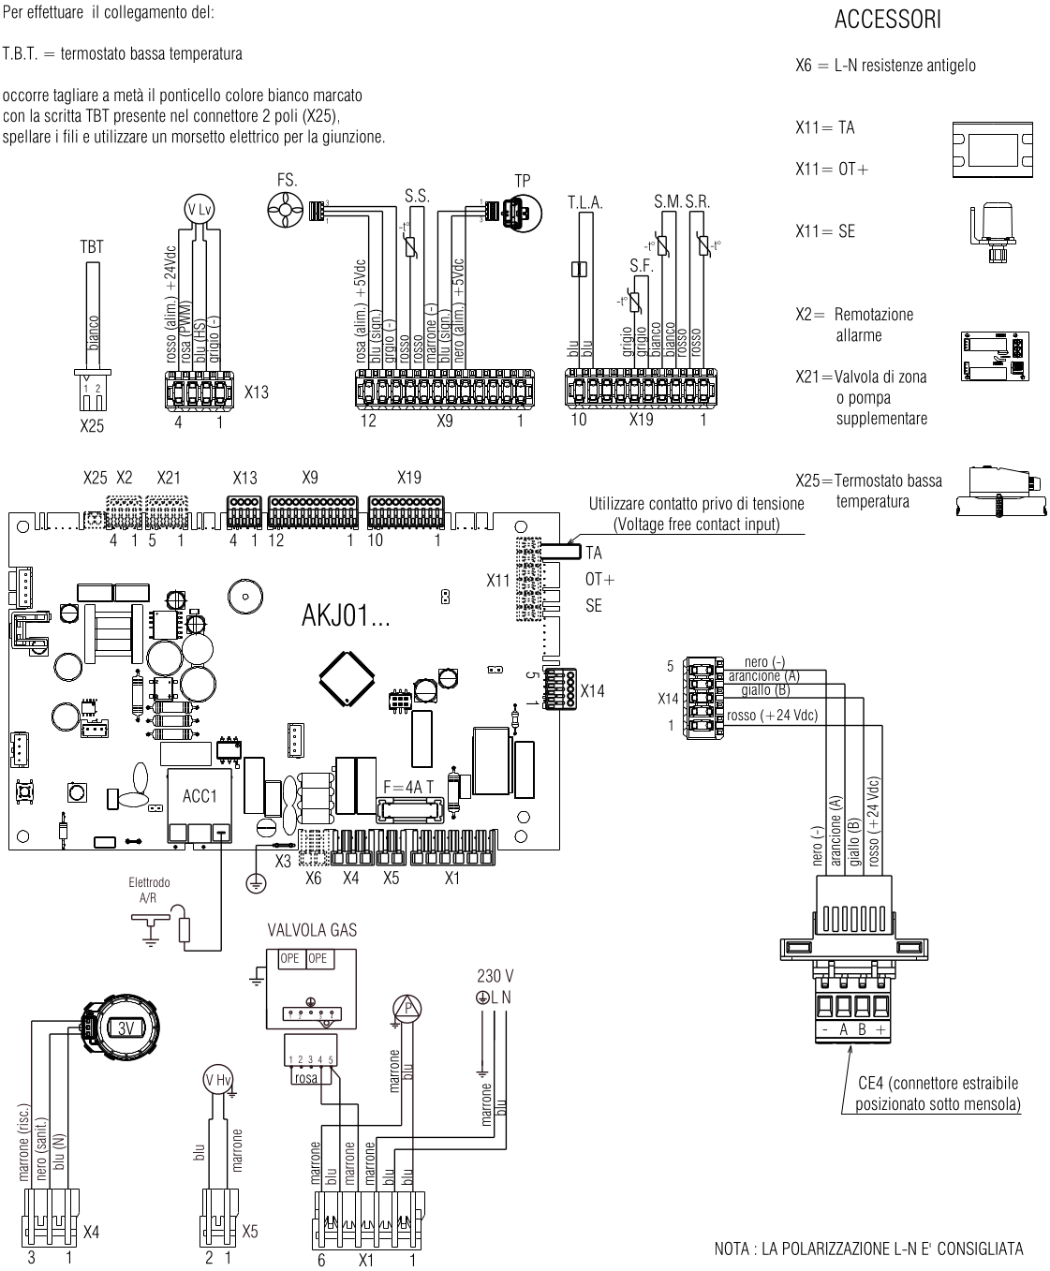
WIRING DIAGRAM:
SPARE PARTS
Regardless of the circulating pump installed in the boilers, as a spare part will be always used the TACO circulating pump code 4R109858.

PLEASE NOTE: starting from October 26th2022, it is available at FIT Service the most recent version of the spare part, in which are available all updated instructions and information. Here attached You can find a copy of those documents.

ATTENTION: the impeller of the three different circulating pumps ARE DIFFERENT AND NOT INTERCHANGEABLE! Spare part code 4R109858 (TACO circulating pump motor) must be installed only with TACO auger!

Hoping to please You, We take this opportunity to extend our warmest regards.

RIELLO SERVICE
Global Aftermarket & Training Manager

The accuracy of the information contained in this communication was verified at the time of its disclosure. However, Riello, pursuing a policy of continuous improvement of its products, reserves the right to modify the specifications at any time. For any further information, please consult the product documentation.

